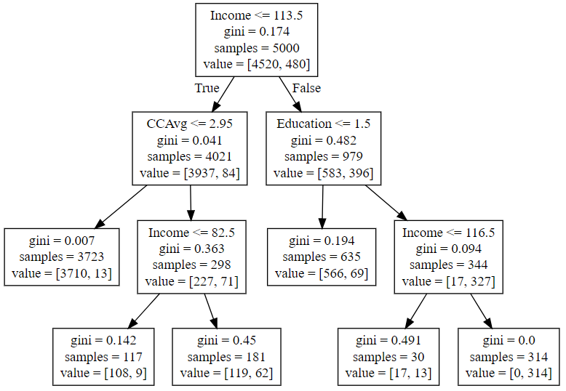

1. Income less than 113.5K has very less chances of loan approval
2. Income less than 113.5K & CCAvg less than 2.95 has almost no chance of approval
3. Income less than 82.5K & CCAvg more than 2.95 has appx 50% chances of approval
4. Graduate & income more than 116.5K has very high probability of loan approval.
5. Below graduation & income less than 116.5K has very small chances of approval